Peace partners UK Charity No 1166456
PEACE PARTNERS ANNUAL REPORT 2021
_________________________________

Table of Contents
Trustees Report 3
2021 Financial Accounts 4
Annual Review for Supporters 6
1. Peace Education 7
2. Humanitarian Aid 9
3. Partnerships 10
4. Organisational Events and Changes 12

Trustees Report

The Board of Trustees
At the start of 2021, the Peace Partners Trustees were: Juli Hammersley (Chair), Barbara Andre, Philippa Lyons, and Pauline Cook. Jenny Spicer acting as Charity Secretary. Chrissie Waite, the lead volunteer for the Peace Education Programme joined the Board of Trustees in January 2021.

Overview of the Year
In June Juli Hammersley, the Peace Partners founder and Director announced she would be leaving and subsequently resigned in July. Our long-standing secretary and administrator Jenny Spicer also left us in the same month. The team extended their heartfelt thanks to Juli for her vision and hard work setting up and running Peace Partners since 2016. And to Jenny for her reliability and amazing organisational skills. Their efforts have been inspirational, and they will both be missed. We wish them both all the very best for the future.

The remaining Trustees decided to cover the vacated roles between them, taking turns in the chair and allocating admin tasks between them as needed. At this time, as the lockdown was lifting, several other volunteers who had joined us whilst furloughed, also left to return to full time employment. Consequently, the next few months saw activities restricted whilst the remaining trustees and core team, together, considered the best way for Peace Partners to react.

In September 2021 we welcomed Jemma Couchman to the Board to oversee Partnerships, marking the beginning of a gradual restructure and strengthening of the Board.

In October, the Trustees communicated with our supporters advising them of the situation, whilst assuring them that we would continue to operate our core functions. We were heartened and humbled by the loyalty of all our supporters, who continued their financial giving throughout this time of restructuring and offered many messages of encouragement. As a result, in 2021 Peace Partners was able to disburse grants totalling over £19,500 to UK and overseas humanitarian causes.

In November, the Trustees and Core Team held a strategy meeting to decide how best to move forward. The meeting was very positive and showed what a great and enthusiastic team we have. Together it was decided that immediately and through into 2022 we would begin to recruit new people to cover key roles and strengthen our team.

Structure, Governance and Management
The board of trustees continued to hold Zoom conference calls on a fortnightly basis. The meetings deal with matters of governance and management with relevant information communicated to and from the core management team.

The year ended on a positive note as we consolidated our strengths and looked forward to a fresh approach and new opportunities to make a difference in the lives of those most in need.

2021 Financial Accounts

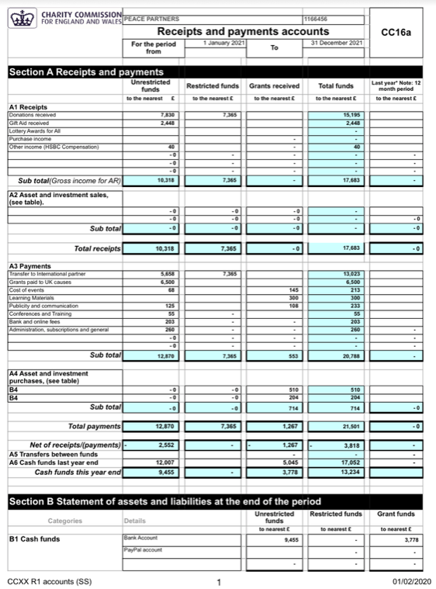

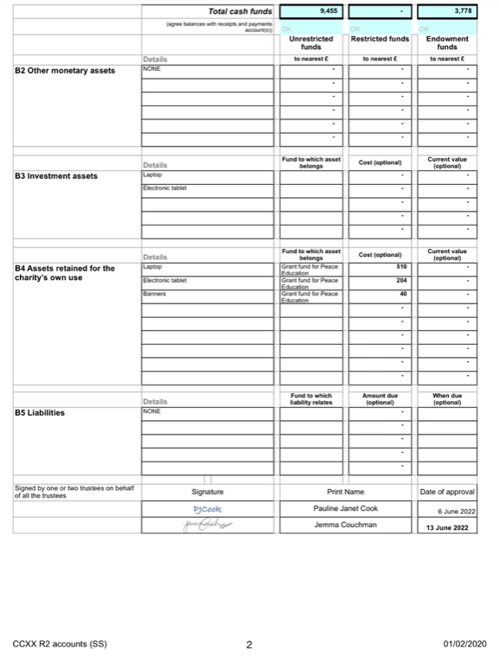

Annual Review for Supporters

Welcome to Peace Partners 2021 annual report summary for supporters!

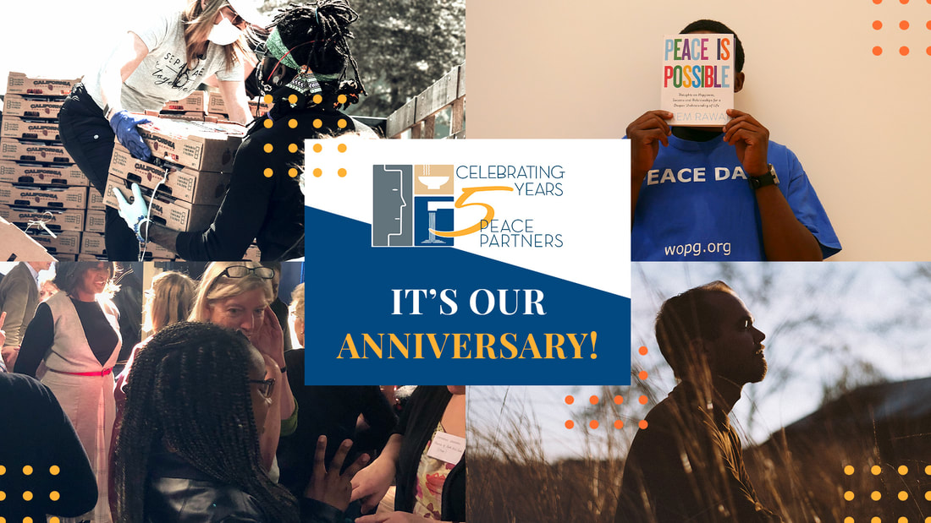
This year’s summary reviews the activities undertaken in our key areas of engagement: peace education, humanitarian support, and partnerships; and in conclusion we also review the main organisational developments that took place.
At the beginning of the year team director, Juli Hammersley, spoke about our aspirations: "Even though ‘Lockdown 3’ is underway, we are continuing to move forward with our projects and the aims of the charity, taking on board new and innovative ways of running projects online and working in different ways. As a charity that focuses on personal peace and humanitarian work, we are passionate about making a difference to people who need support at this time. I am hugely grateful to our trusted volunteers, team, supporters, donors, partners and associates, who have all stepped up to make a difference."

1. Peace Education

Virtual Peace Education Programme Workshops
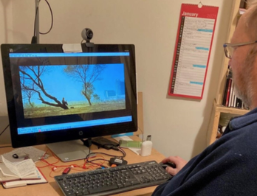

Peace Partners hosted virtual public Peace Education Programme workshop courses, which continued with great success.

The quality of the course is evidenced in the feedback and reflections of participants, demonstrating the depth of feeling and respect elicited:

“It’s been absolutely a privilege and an honour being part of the Peace Education Course”

“It’s been an odd year, and what do we value? Just be content with who’s around me and what I do have, so many blessings …. We need to be reminded we have that choice. Sometimes the outside gets overpowering, and we forget. We can’t make things disappear, but I can choose how I react, I can choose to appreciate.”

“I may not have gone to a live course, but this worked out really well for me.”

Team members involved in hosting the courses also expressed their appreciation:

“One positive outcome from this time of Covid has been to be able to take this unique message directly into people’s homes ... Due to the pandemic all the programmes taking place locally had to be cancelled, and I was originally cautious about how this would work virtually - and to say ‘Yes’ was one of the best choices I have made.”

“It was a great pleasure working with such a positive, dedicated, and lovely team of people; to share the profound messages of the Peace Education Programme, and to be reminded of our inner resources, how wonderful they are and that they are always there. Definitely a Win, Win, Win for me! ”

Later in the year Peace Partners volunteers helped in establishing virtual courses in a South London college for students and staff. The courses were also part of a pilot programme conducted globally by The Prem Rawat Foundation to investigate the best use of the programme in educational settings.

Peace Education Network

Peace Partners is excited to report that in September we accepted an invitation to become a partner in the newly formed global Peace Education Network (PEN) . Its inaugural Peace Education Day Conference was held virtually on 20th September. The goal of the conference is to assemble a global network of peace educators and establish a United Nations Peace Education Day recognising that peace building skills, strategies, and structures are foundational to all other humanitarian endeavours. 1,600 people from 86 countries attended the Zoom webinar, and another 1,500 people from around the world viewed the livestream version. A keynote speech was given by Prem Rawat, founder of The Prem Rawat Foundation (TPRF) and The Peace Education Programme.

2. Humanitarian Aid

Fundraising Quiz in aid of Centrepoint
Peace Partners first virtual fundraiser quiz, in aid of Centrepoint and their work with homeless young people during the pandemic, was hosted in late February.

More than 50 guests participated, and donations reached our target amount of £1500! You can read our report about the event here.
The Prem Rawat Foundation’s India and Brazil Covid Relief

In May we ran a fundraising appeal in support of our core partner TPRF’s campaign to provide medical care and supplies for COVID-19 relief in India and Brazil, countries which were suffering from intense outbreaks of the disease at the time. In total, including online donations and a grant from our own resources over £1750 was raised. You can read about the TPRF campaign here.

The Prem Rawat Foundation fundraising appeals

Peace Partners supported both of TPRF’s seasonal appeals during 2021. For the Looking Forward appeal in June £1330 was donated, and for the Reaching Out appeal in December £1236 was raised. Both appeals featured newly produced short videos highlighting the current work of TPRF. These were featured on our website, in our eBulletin and on social media channels to, hopefully, increase awareness of the inspirational peace and humanitarian initiatives undertaken by the Foundation.

Fundraising Impact

The overall impact of Peace Partners’ fundraising initiatives in 2022 for humanitarian causes and in support of peace education, through regular and one-off donations and through the campaigns we have supported, can be viewed through the Financial Accounts section of this report.

3. Partnerships

Here is a brief review of the activities undertaken in collaboration with some of our partners in 2021.

Earth Day
Thursday 22nd April was UN Earth Day, and Peace Partners joined with partners Peacecast.tv in celebrating the day. The theme this year was ‘Restore Our Earth’ and official events were focused on what individuals can do to drive change.
During the day Peacecast.tv broadcast inspiring and entertaining videos highlighting activities in countries worldwide using their web-platform, with Peace Partners providing a curated video playlist for England.

You can view the playlist and all our celebratory activities, including our Peace Tree and our interview with Friends of the Earth, by visiting our dedicated Earth Day web-page here.

Peace Day
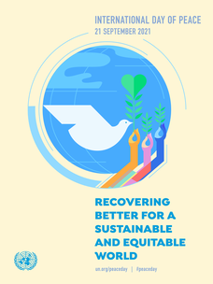
21st September was the UN International Day of Peace. This year’s theme was ‘Recovering Better for a Sustainable and Equitable World’. Once again, we celebrated the day in collaboration with PeaceCast.tv. Our curated video playlist was included in their 48-hour streamed broadcast that played throughout the day’s duration anywhere on the planet! You can view the broadcast here.

Our Peace Day 2021 webpage featured the broadcast along with several other inspiring initiatives which celebrate peace as a fundamental and enduring value. You can view it here.

Pledge to Peace
As a signatory to the Bruxelles Pledge to Peace since 2016, we are invited to report on our activities annually: ‘In recognition of The United Nations General Assembly resolution 55/282 of 7th September 2001, which states that the UN International Day of Peace shall be observed on 21st September each year for the celebration and observance of peace, the parties agree to announce, report and publicise their respective on going and/or specific peace initiatives on September 21st.’ You can read our 2021 report to Percorsi, the Pledge’s secretariat, here.
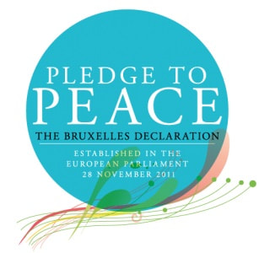
The Pledge to Peace celebrated its 10th anniversary in November, you can read our article about it here.

TPRF 20th Anniversary

This year marked twenty years since the inception of The Prem Rawat Foundation (TPRF). In 2001 Prem Rawat stated that his foundation's mission was to advance dignity, peace, and prosperity across the world by addressing the fundamental human needs of food, water, and peace.
​
Peace Partners volunteer Wendy Martin organised a virtual interview with Marci Klein, TPRF Development Director in charge of fundraising, and Jake Frankel TPRF Communications Director about the Foundation’s 20th Anniversary Celebrations.

Read our news post about the interview and the occasion here.

4. Organisational Events and Changes

Strategic Plan Development

At the start of the year, we identified our three main objectives for 2021:
- Focus on existing networks of partners, supporters, and associates. To ensure we maintain and develop the potential benefits of these relationships.
- Inspire and create change through all our projects, including The Prem Rawat Foundation’s Peace Education Programme, expanding the reach of the course in the UK, offering support, networking, and raising awareness of the benefits and attributes of this unique course.
- Expand our humanitarian aid projects, reaching out and providing help and assistance when it is needed most.

To some degree these objectives needed to be re-assessed during the course of the year. This is described in the section below about some unforeseen team changes.

Our 5th Anniversary
Our story begins in 2014 when, during a lengthy expedition of India and Nepal, Juli Hammersley saw the transformative power of The Prem Rawat Foundation’s (TPRF) Food for People initiative on local youth and the surrounding communities.
Inspired by the tangible impact of the Food for People initiative on youth and community development, Juli sought to bring these humanitarian values back to the UK, and in 2016 Peace Partners was formed, raising awareness for the development of personal peace and empowerment throughout the country.

Over the next few years and with an ever-expanding network of trustees, volunteers and community partnerships, Peace Partners has grown by leaps and bounds, supporting area food banks, shelters, and peace building workshops that seek to unlock the great potential within.

Learn more about our five-year journey and watch an interview with founder Juli Hammersley here.

Donors Thank You

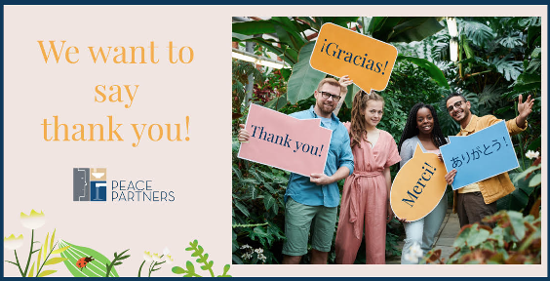

In April we hosted our first ever Peace Partners Donor Thank You event. The hour-long virtual event was our opportunity to express our gratitude for our donors’ support and included: an update on how donations helped make a difference in 2020; our plans for 2021; a live musical performance and some short videos; a presentation from one donor on what it means to offer financial support; and a Q&A session. The consensus amongst both donors and the hosting team was that the event was fun, heart-warming, and inspiring!

Website, eBulletin and Social Media

Activities during the year were reflected through our main communication platforms: the website, the regular eBulletin, and on social media (Facebook, Twitter and Instagram).

The website featured regular news blog posts and posts on our ‘Writings for Peace’ blog, as well as updates to our more permanent web pages. eBulletins and newsflash mailings were distributed to our growing subscriber list on a regular basis (the archive can be viewed here). The aim was to reflect new postings across all three platforms.

Leadership and Volunteer team changes

As a small charity with an all-volunteer part-time staff, we are highly dependent on the availability and expertise of our team members. 2021 marked a significant time of change for the make-up of the team, and the second half of the year saw our strategic plan revisited and revised in light of these changes.

Juli Hammersley, founder, and director for five years, decided to step down in July because of personal commitments. We are indebted to Juli for her inspiration, efforts, and courage in establishing Peace Partners as the viable and successful organisation it is (see the 5-year anniversary entry above for more about Juli). Juli’s vision and personal contact and engagement with volunteers was something we quickly realised would be hard to replace!

Additionally, Jenny Spicer, our long-term administrator, let us know that she too needed to step back because of competing commitments. Jenny is a first-class administrator and had been closely involved in our successful bid for our community National Lottery award, so we knew that hers would be a big loss too.

There is an inevitable evolution in the membership of any volunteer team, so along with some other ongoing team changes the trustees and the core management team were faced with a resourcing challenge, at a time when changes as consequence of the continuing pandemic were already significant. Much of the latter part of the year was needed to revise our strategic priorities, to ensure that Peace Partners could continue to meet its key objectives. Special thanks are due to our governance trustee Philippa Lyons, who, with her considerable experience of the voluntary sector, was able to steer us in a realistic and achievable direction!

Thank you for your continued support and interest during the year, which has made a real difference to the quality of life of many individuals across the planet. Our all-volunteer team very much looks forward to furthering our collaborative efforts during 2022.

With gratitude,

The Peace Partners Team

